INFO 6350 Final Project Report

Xuan Gao

001220084

1. Introduction

As a student, we always face tests and quizzes. It is extremely useful to have an APP that we can practice and do the tests every day and everywhere. I notice that NEU lack of an application like this.

So here is the NEU Test System APP! Students can use it to do time limited tests and do practices all the time! For the test part, you can see you last time and grades. For practice part, it has randomly question mode, sequence mode and questions divided by chapters. For each view, you can select which question to do and get the answer.

You can also watch some teaching videos at the main page as well as go to some useful links like Blackboard.

1. Flow

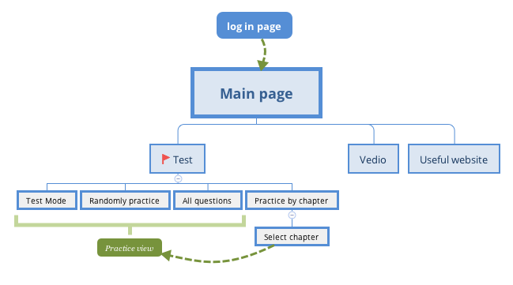

Function relationships

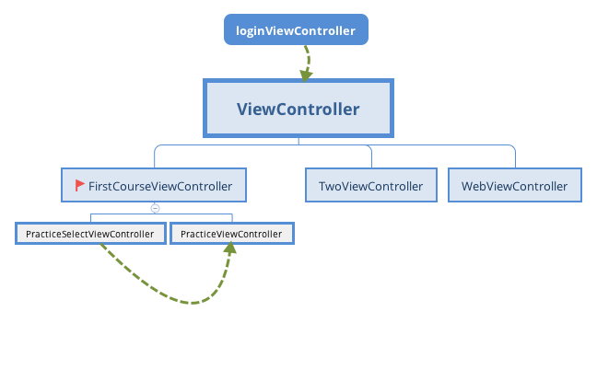

View relationships

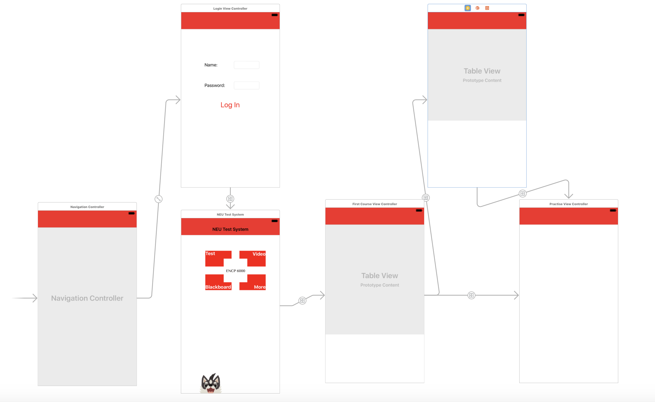

View relationships through storyboard

1. Design

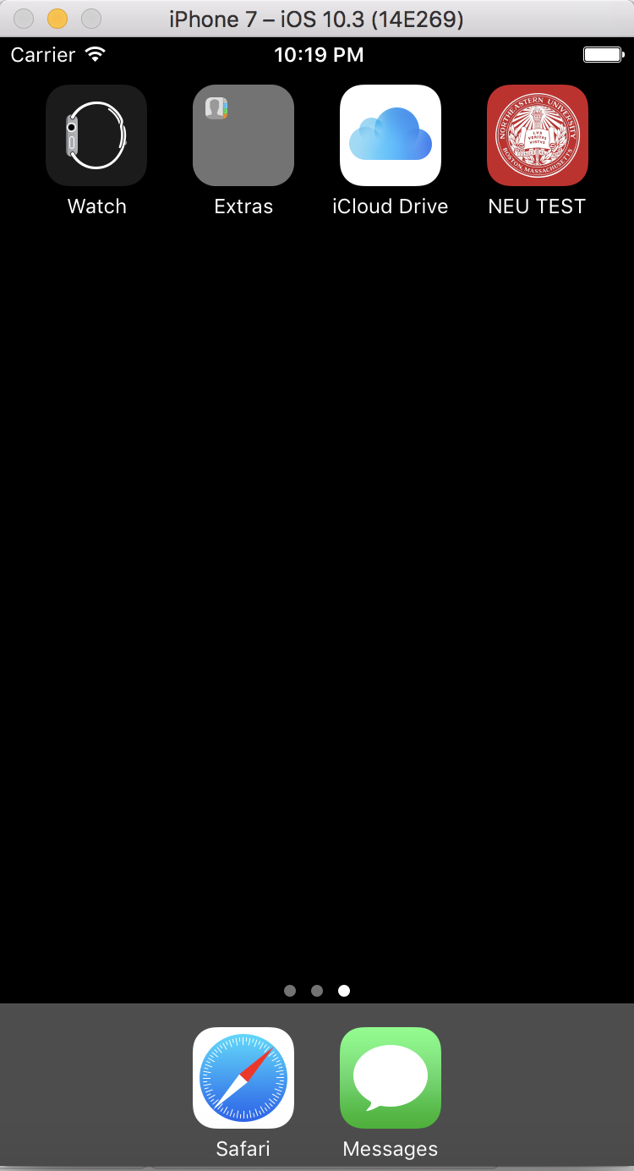

Icon and Description

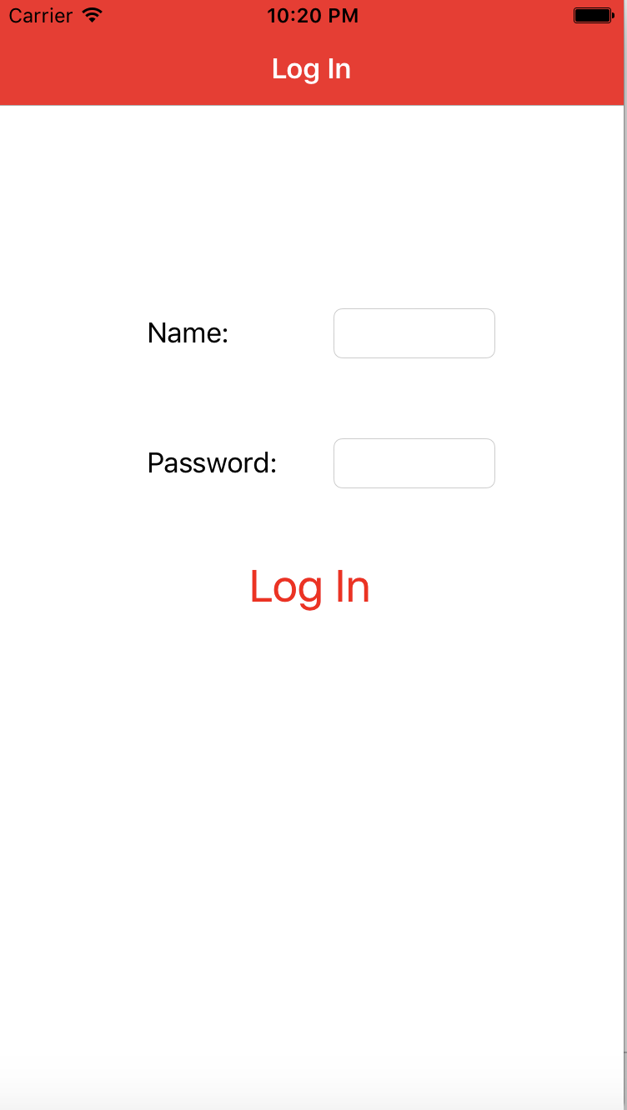 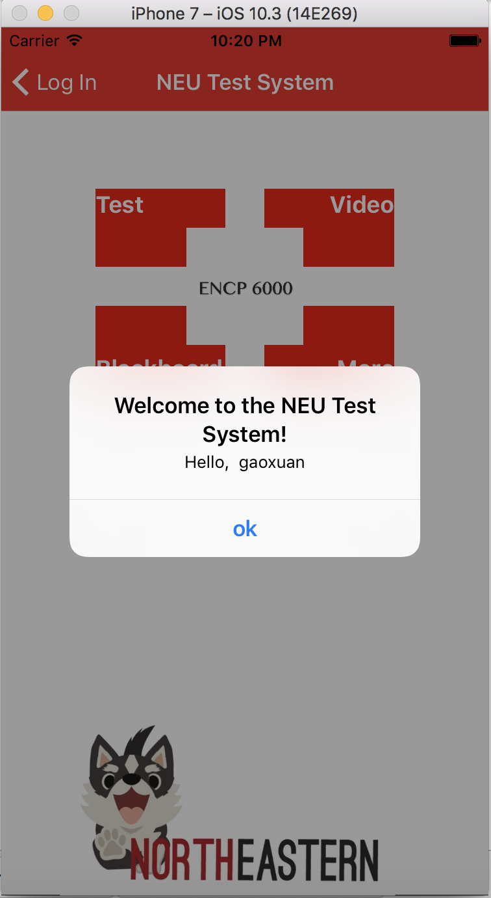

login page login successful

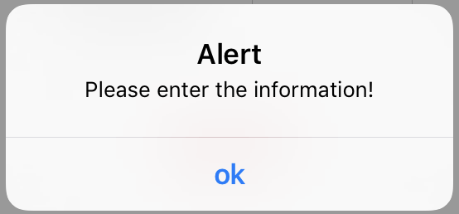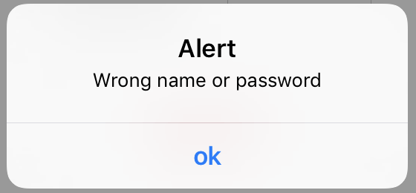

login validation

Student needs to enter correct name and password. Textfield can not be empty.

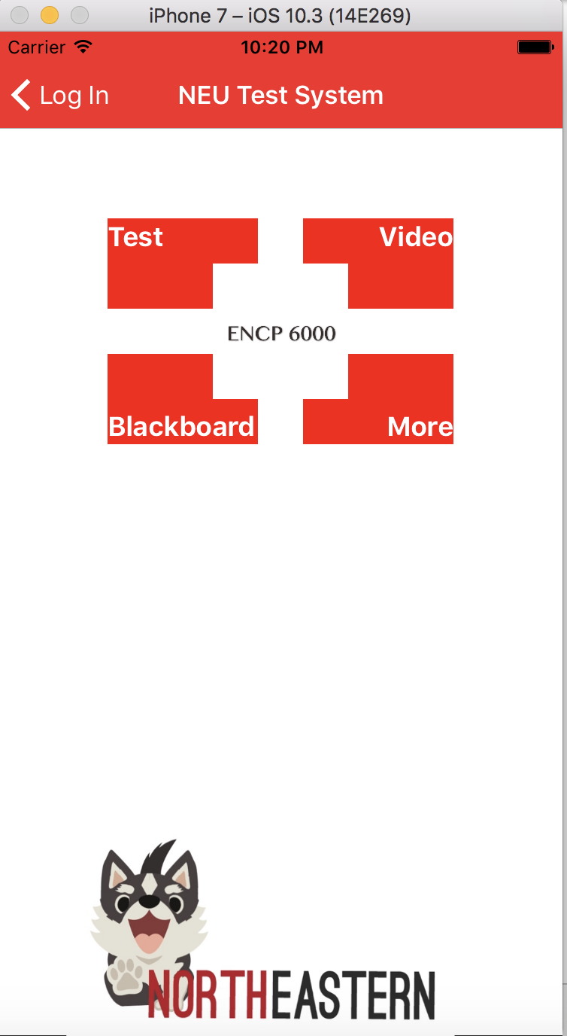

Home page

It has four sections, Test, Video, Blackborad and More.

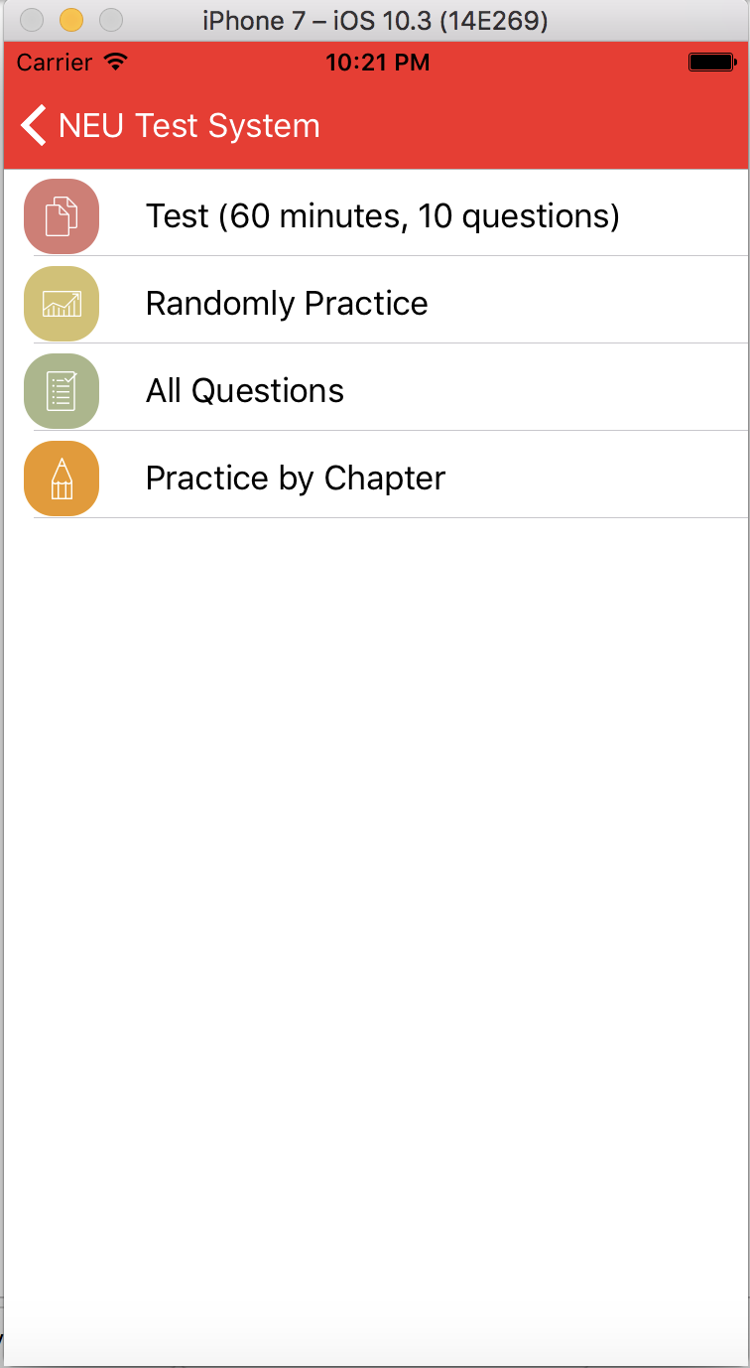

Test Section

There are four modes. Time limited test, randomly practice, all questions and practice by chapter.

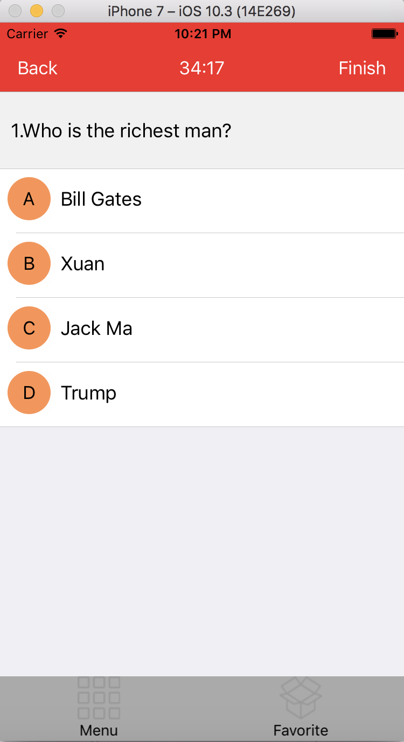

Test Mode

The navigation title will show the last time. And there are back and finish button.

The bar items are menu and favorite.

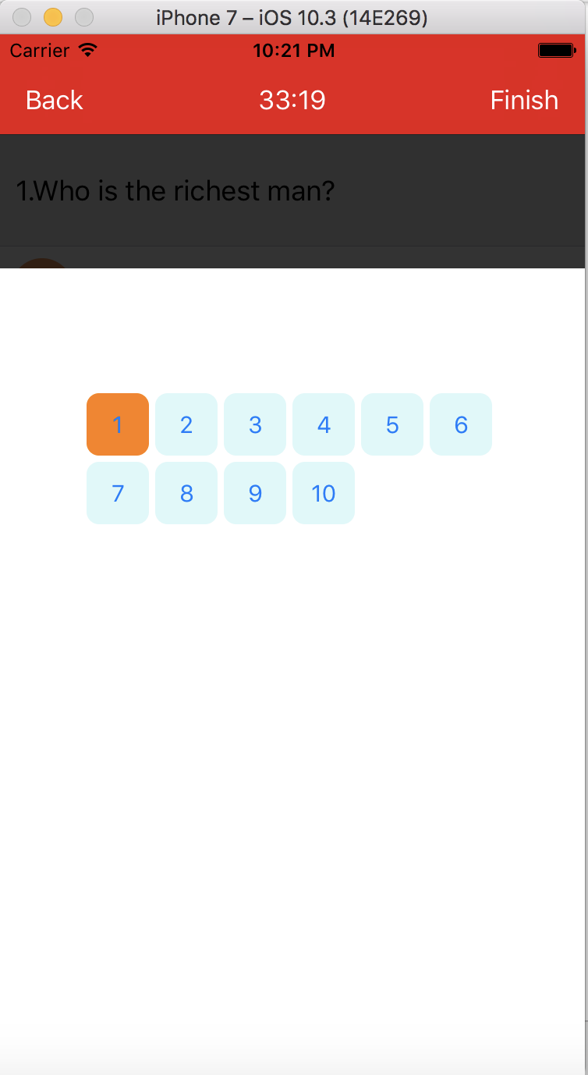

Menu sheet

You can choose to do which questions.

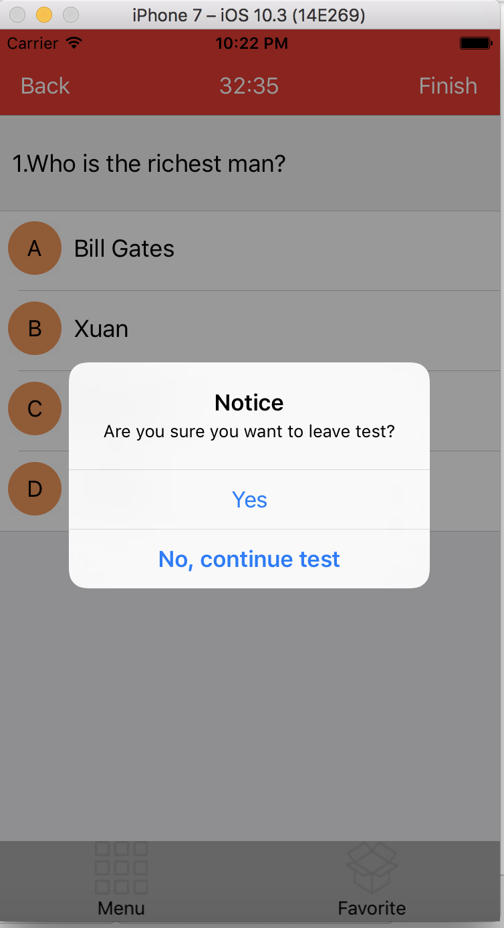

Back alert

When you click back, it will notice you whether stay on this page or not.

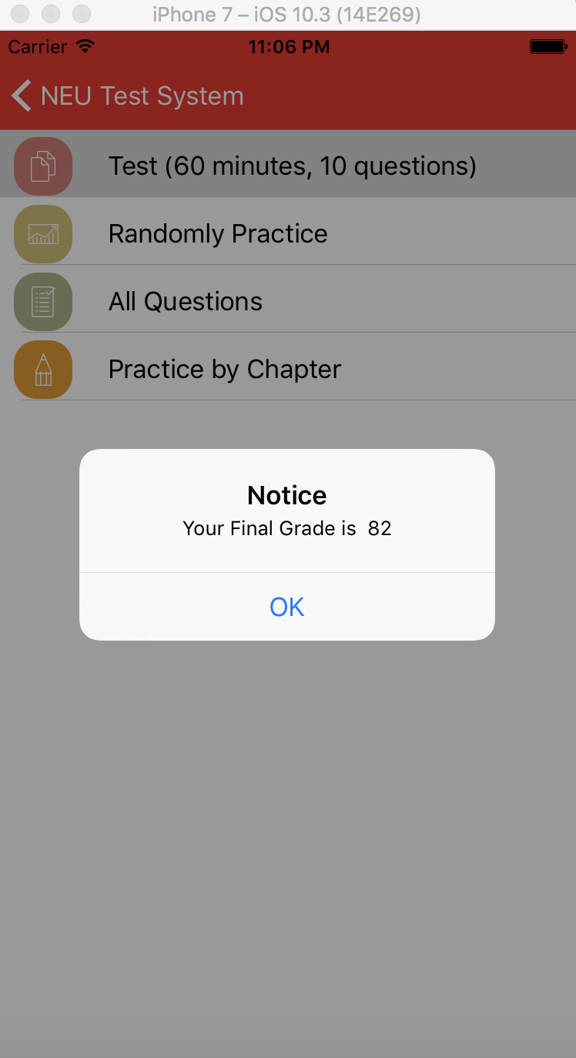

Finish

When you click finish the test, you will see your grades.

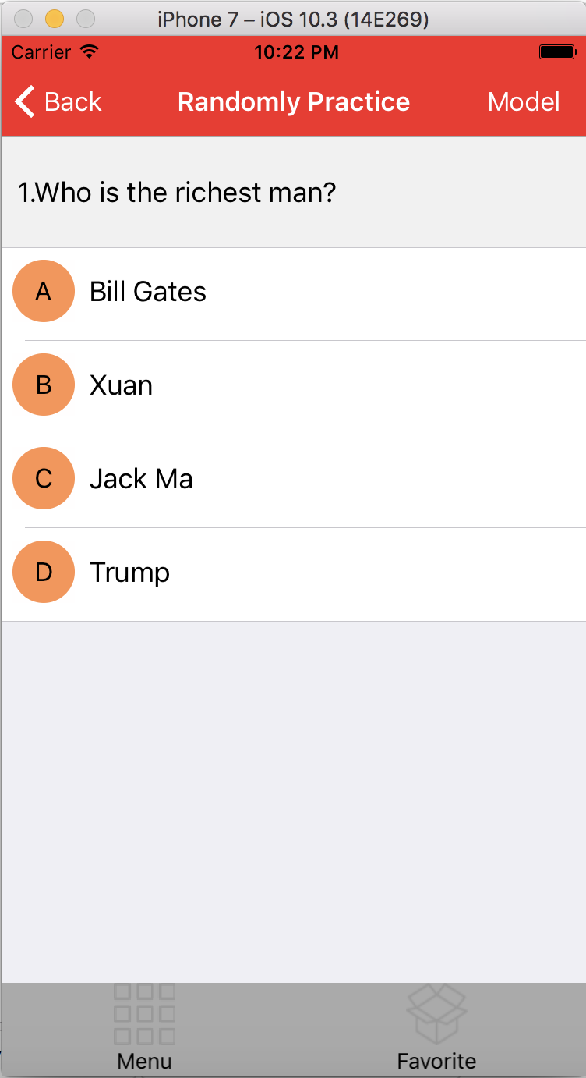

Randomly practice

It will randomly give you several questions to practice.

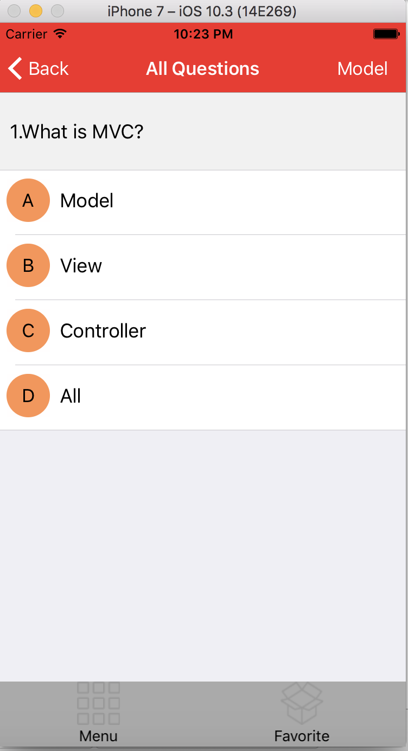

All Question mode

You will see all questions in sequence. The bar items are same with the test.

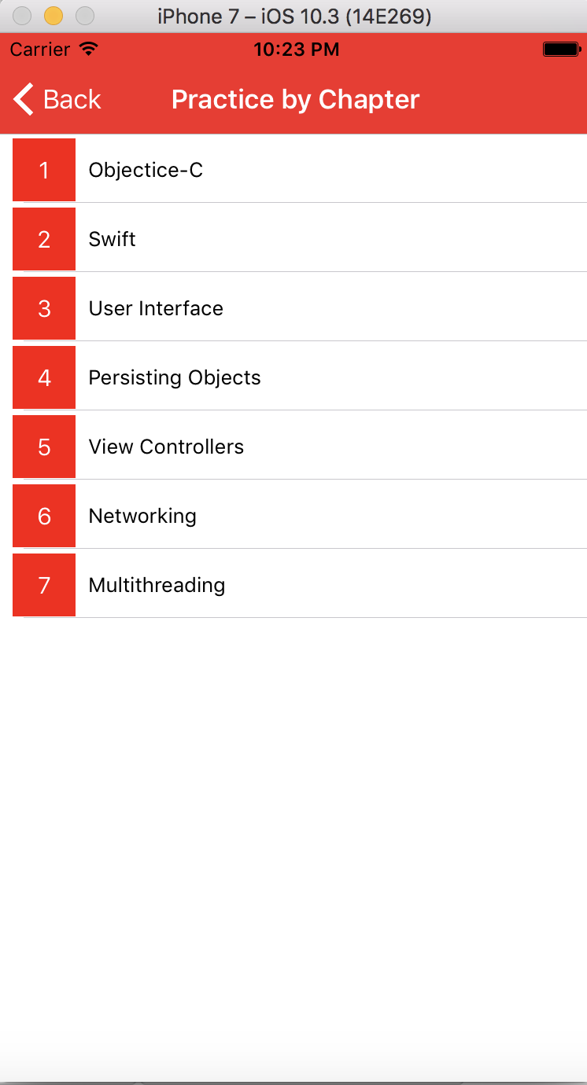

Practice by chapter

You can choose questions ordered by different chapters.

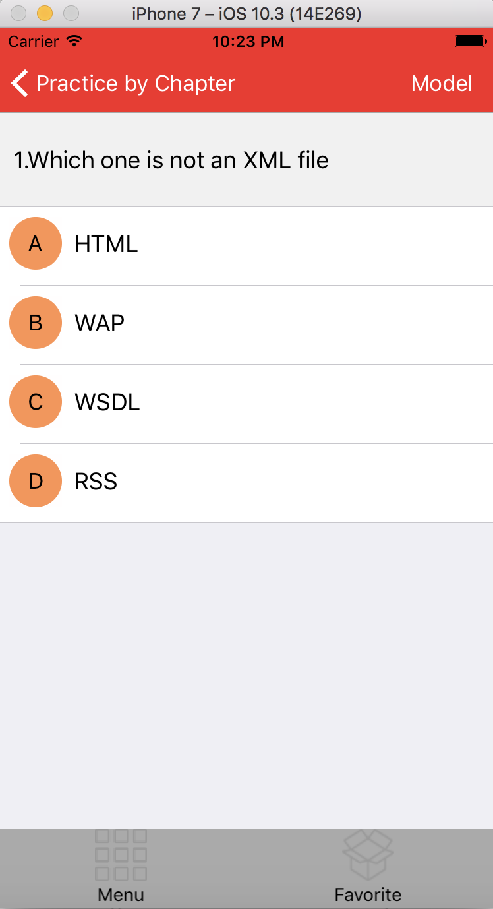

Answer page

This page are same with the randomly practice and all questions page. Only the content is different. It will only show the questions in this chapter. Same with menu.

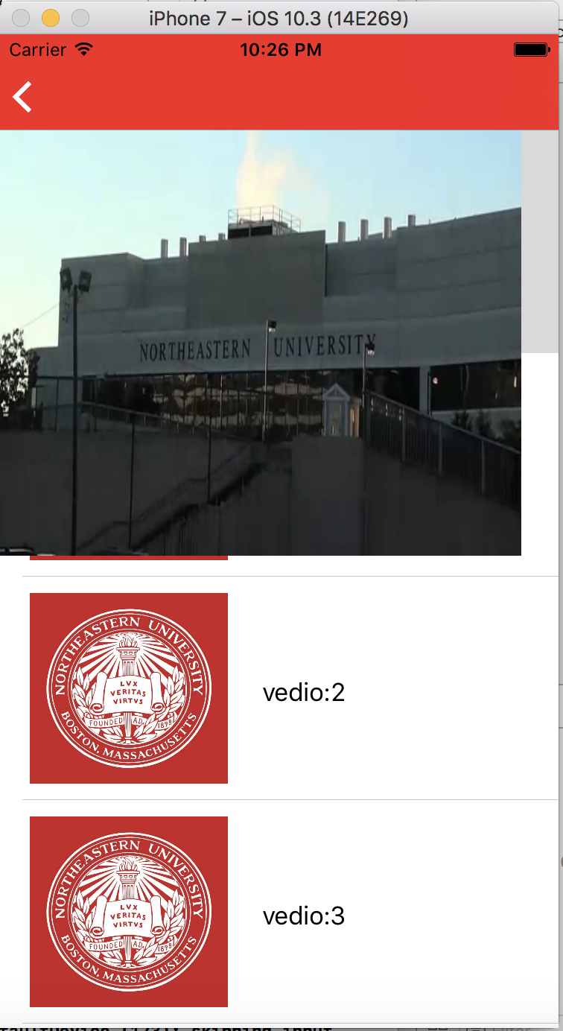

Video page

You can watch some videos through this page.

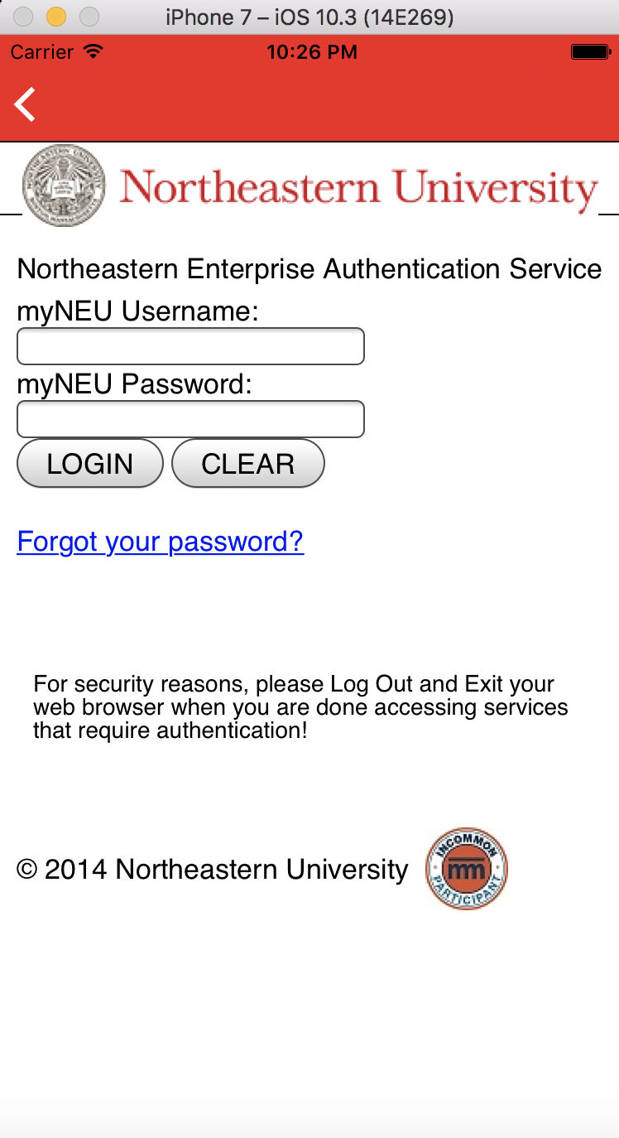

web page

You can directly go to some useful website through this APP.

1. Technologies
2. Database

I use FMDB which is a third-party sqlite database. It is useful and easily to use.

1. Interface reuse.

All the four practice modes are use the same PracticeView. It reduces the code and make it more clear.

1. UI design

One of the most important part in my project is the UI design. I added some animation such as menu sheet, course select etc. I used countless CGRectMake. So the developer should really familiar with the interface.

1. Future enhancement
2. I almost finished the “favorite” function, you can see the array print out at the console, but I have no time. This part will be soon finished.
3. For the “model” button at the navigation, I finished the UI part, and you click “test” will return 0 and “review” will return 1. You can see the result at the console, but I considered this part is not necessary, so I am not work on it.

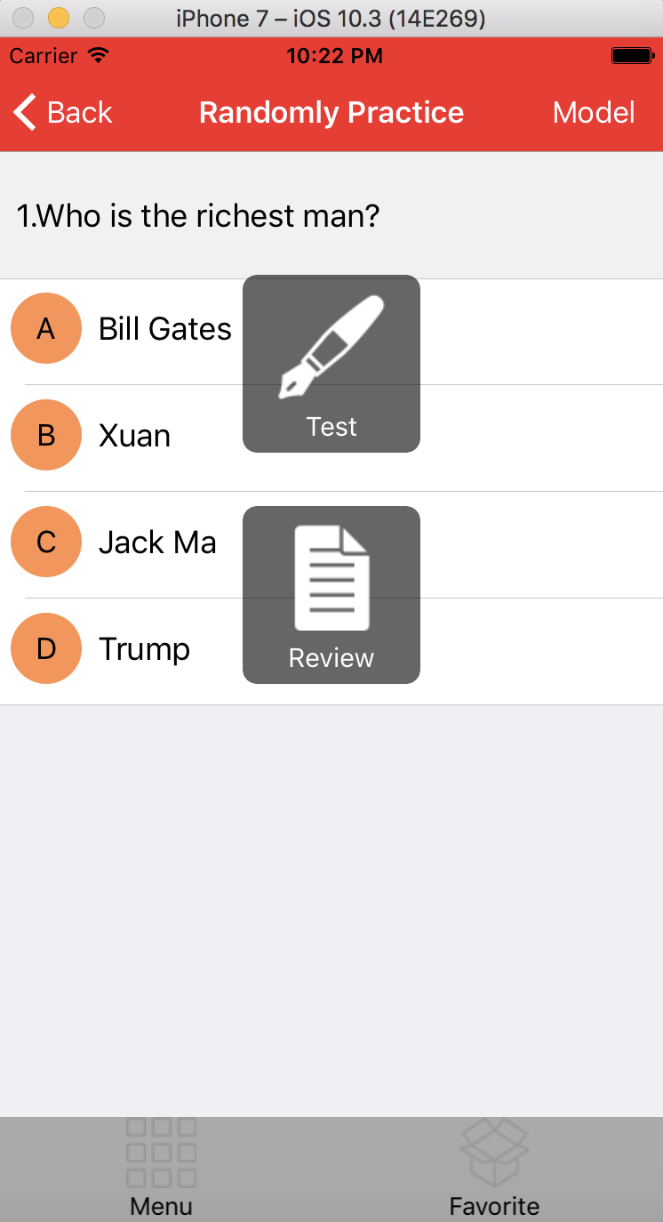

Model select UI

1. On the main page, actually you can choose which course you want to practice. But now I only have one database and all coursed are use this database. So I will divide them in the future.

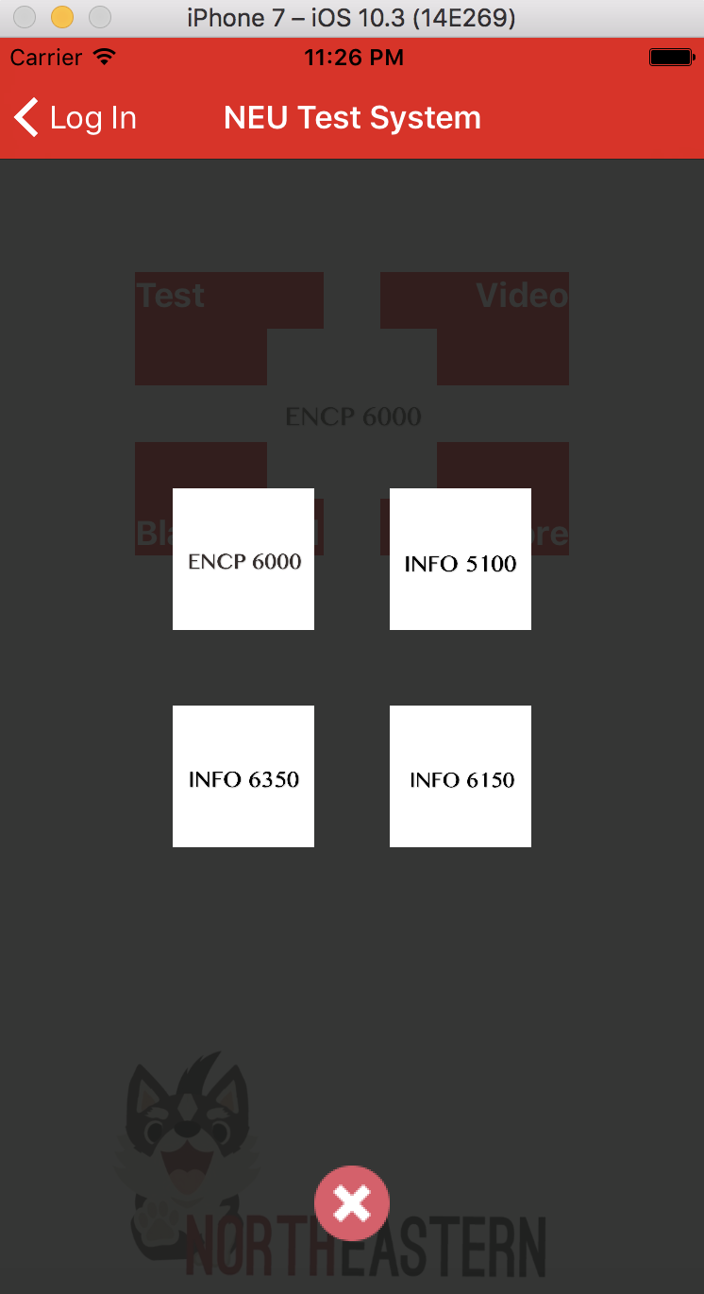

Course select

1. I need to continue finish the menu sheet. It can show the questions are correct, wrong or not attempt. I already write some codes in StatisticsViewController but not finished.
2. When you finish the test, you will see the grades. The algorithm now is not correct. Because it stores all the wrong questions now. Maybe you did the test several times, and it will record all the wrong questions in the array. I still need to work on this part.
3. There are also a lot of parts I can enhance in the future. Such as extend database, add question types and send the grades to another database so that the professor will know. I also try to add pictures in the database. Also for the login part, it still needs a database to record information about different students. I hope it can be a real APP in the future, so the students can practice everywhere.
4. Others

I learned a lot from this course, and I feel real achievements during this semester, especially in the final project. At the begin of the semester, I knew nothing about ios development and objective-c. This course is a little bit hard for me, but push me to work harder and harder. Thank you so much professor, I will recommend my friends to take this course. There are also some suggestions. The ios develops so fast, now it is ios 10. There are many difference between ios earlier and 10. So it is helpful to introduce more about the newest technology in slides. Thank you.